**File Management**

**1. Create, Rename, or Delete Multiple Files Based on a Pattern or Criteria**

**Creating multiple files:**

bash

# Create 10 files named file1.txt, file2.txt, ..., file10.txt

for i in {1..10}; do touch file$i.txt; done

**Renaming multiple files:**

bash

# Rename files with .txt extension to .bak extension

for file in *.txt; do mv "$file" "${file%.txt}.bak"; done

**Deleting multiple files:**

bash

# Delete all .bak files

rm *.bak

**2. Organize Files into a Specific Directory Structure**

bash

# Create directories for each year and month, and move files accordingly

for file in *; do

year=$(date -r "$file" +%Y)

month=$(date -r "$file" +%m)

mkdir -p "$year/$month"

mv "$file" "$year/$month/"

done

**3. Back Up or Archive Important Files**

bash

# Create a tar archive of the important files

tar -czvf backup.tar.gz important_file1.txt important_file2.txt

**Text Processing**

**1. Search and Replace Text Within a Group of Files**

bash

# Replace 'foo' with 'bar' in all .txt files

sed -i 's/foo/bar/g' *.txt

**2. Extract Specific Information from Log Files or Data Sets**

bash

# Extract lines containing the word 'ERROR' from a log file

grep 'ERROR' logfile.log

**3. Format Text Files in a Particular Way**

bash

# Add a header to each text file

for file in *.txt; do

echo "Header Text" | cat - "$file" > temp && mv temp "$file"

done

**Scripting Example**

You can combine these commands into a shell script to automate complex tasks. Here's an example script:

bash

#!/bin/bash

# Create multiple files

for i in {1..10}; do touch file$i.txt; done

# Rename files with .txt extension to .bak extension

for file in *.txt; do mv "$file" "${file%.txt}.bak"; done

# Delete all .bak files

rm *.bak

# Organize files into directories based on their modification date

for file in *; do

year=$(date -r "$file" +%Y)

month=$(date -r "$file" +%m)

mkdir -p "$year/$month"

mv "$file" "$year/$month/"

done

# Back up important files

tar -czvf backup.tar.gz important_file1.txt important_file2.txt

# Search and replace text within files

sed -i 's/foo/bar/g' *.txt

# Extract lines containing 'ERROR' from log file

grep 'ERROR' logfile.log

# Add a header to each text file

for file in *.txt; do

echo "Header Text" | cat - "$file" > temp && mv temp "$file"

done

Save this script as file_management.sh, make it executable, and run it:

bash

chmod +x file_management.sh

./file_management.sh

TASK1:

File Management:

Create, rename, or delete multiple files based on a pattern or criteria.

Organize files into a specific directory structure.

Back up or archive important files.

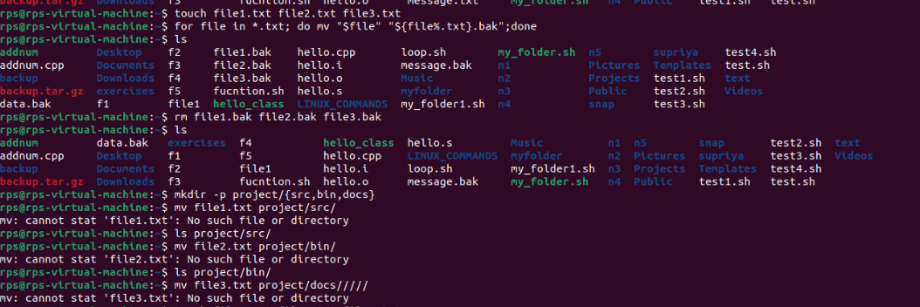

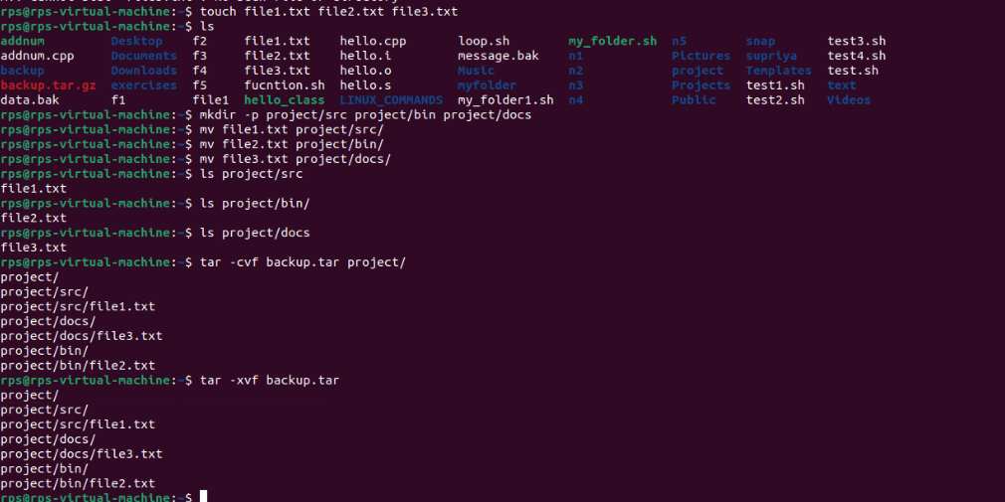

Text Processing:

Search and replace text within a group of files.

Extract specific information from log files or data sets.

Format text files in a particular way

